**Creating table and inserting the data**

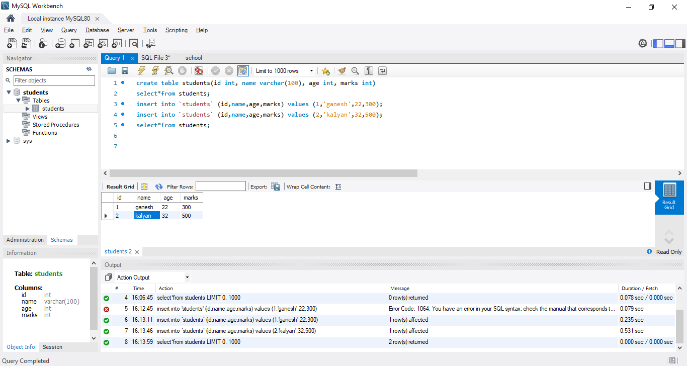

ALTER

ADDING THE COLUMN:-

alter table students add column result enum('pass','fail')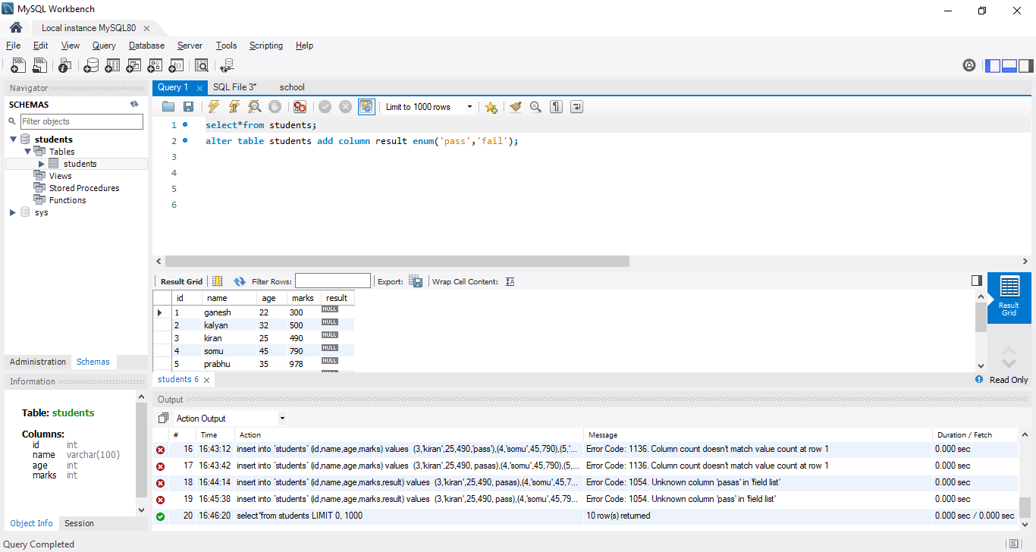

DROPING THE COLUMN:-

select*from students;

alter table students drop column result;

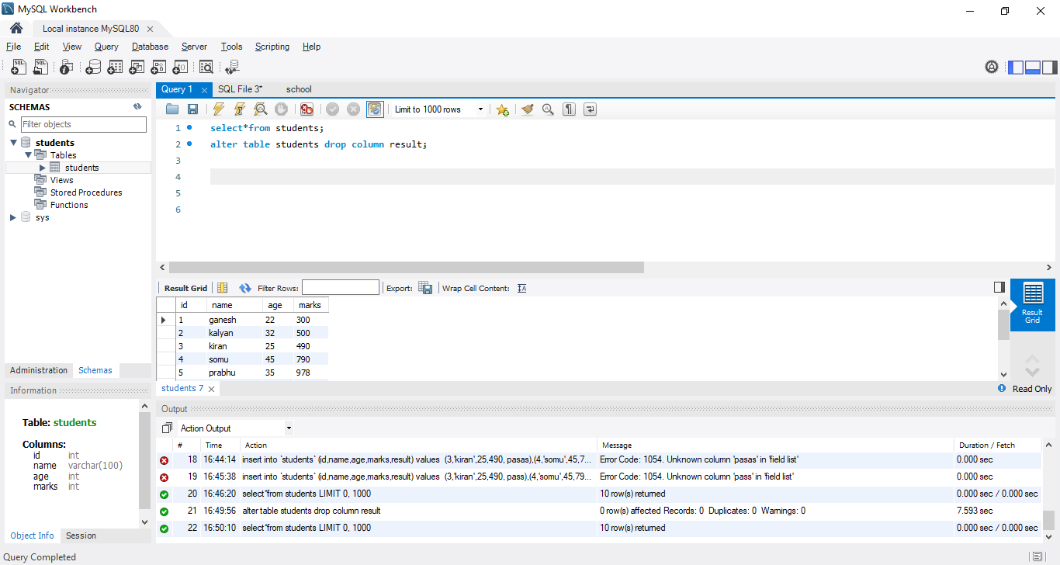

MODIFYING THE COLUMN:-

select*from students;

alter table students rename column `name` to `students_Name`

alter table students modify column`Students_Name`varchar(50); 